

**UNIVERSITY OF PETROLEUM & ENERGY STUDIES**

**SCHOOL OF COMPUTER SCIENCE**

***Department of Cybernetics***

**GRAPHICS AND ANIMATIONS TOOLS**

LAB FILE

SESSION(2020-21)

Course: BTech with specialization in Open Source & Open Standards

Submitted to: Submitted by:

Dr. Durgansh Sharma Surabhi Kumari

Associate Professor SAP: 500063663

Department of Cybernetics Roll no: R100217101

**Experiment-6**

Design of 3D Hut using Blender

1. Open Blender

2. Create a blank file and delete the default cube.

3. Add a plane and scale it to an average area of a hut, using Shift+A>S.

4. Switch to edit mode using TAB.

5. Add some loop cuts using CTRL+R, to create a division of rooms inside the hut. Loop cuts are needed to be added with respect to X and Y axis.

6. Now delete any one face to bring the plane in L shape and extrude(E) it with respect to the z-axis such that it is equal to the two floors.

7. To make a triangular-domed roof, extrude from middle from both ends of the hut. Add a similar plane in between both floors to differentiate between them.

8. Now add some pillars to the HUT by adding a plane first and then by scaling it with respect to z-axis. Now add the same pillar to every corner by just duplicating it. (shift+D)

9. To create the roof, add a cylinder apart from the hut. Switch to wireframe mode and select the half of cylinder and delete the vertices. Now duplicate it using (shift+D) and rotate it 180 degree and align both cover each other. Now add an array modifier (x-axis)and increase the number according to the length of the roof. Add a second array modifier (y-axis) and increase the number according to the breadth of roof.

10. Add the same to the top of hut by tilting it according to shape of the hut. And add the copy of same to other parts of roof.

11. Now add a camera and a light source to it. And arrange the camera to the best fit view.

**OUTPUT SCREEN:** 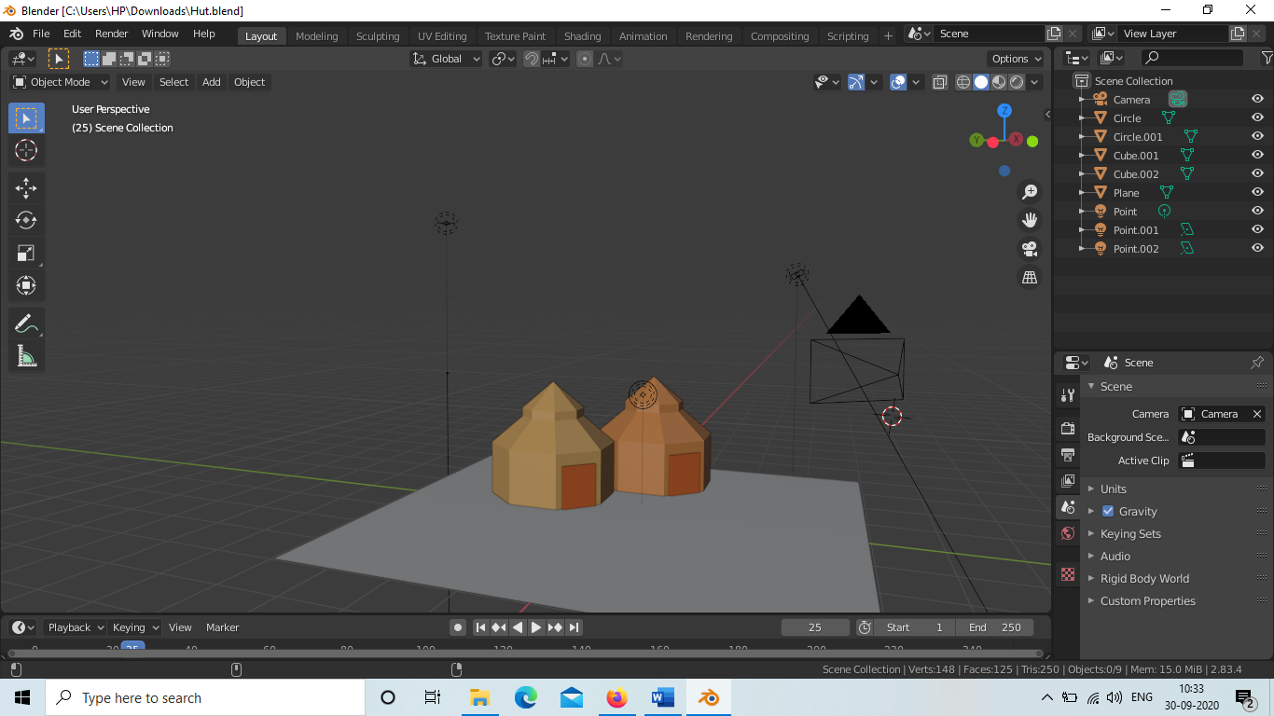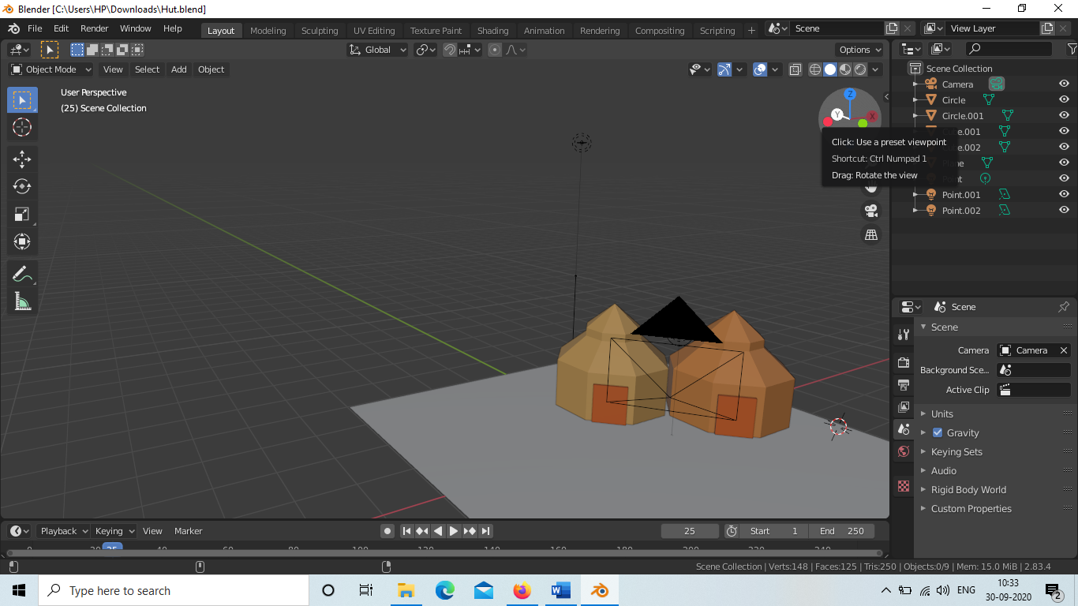

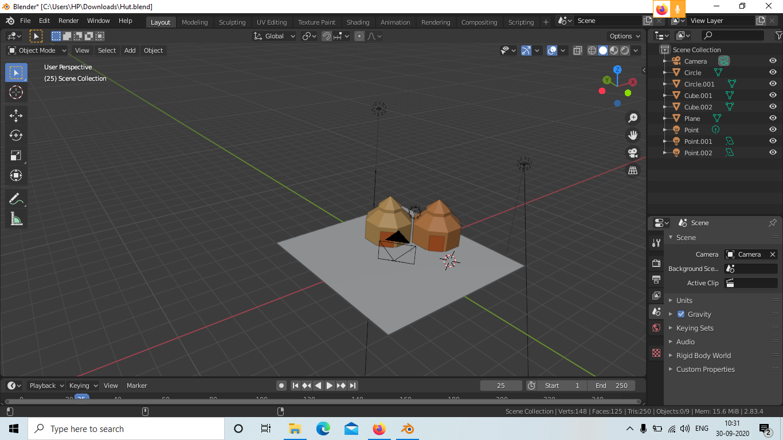

[Link of Experiment](https://drive.google.com/drive/folders/1D7zNhJVP_u_w6TcOHdshBVOxzQsQpDIo?usp=sharing)